**Trafficviz**

Final Year Project Proposal

(BSCS)

By

128

|  |  |  |  |  |
| --- | --- | --- | --- | --- |
| S# | **Name** | **Registration #/Roll #/Section** | **Mobile #** | **Project ID** |
| 1. | Muhammad Umar Farooq | Fa-2017/BSCS/317 - G | 0301-5339926 |  |
| 2. | Muhammad Usama Javed | Fa-2017/BSCS/323 - G | 0306-4718518 |

**Supervised by:**

Sowaiba Khan **___________________ (**Signature**)**



Department of Computer Science

Lahore Garrison University

Lahore

**Abstract:**

Increasing load of motor vehicles on the roads results in higher accidents rates as well obstruction in the traffic flow. In this system, we aim to add 3 features. A hologram will be placed in the traffic system. It will help a traffic warden to manage all the traffic from his office through the hologram. Second feature is to detect the ambulance using DIP and GSM technology. A CMOS image sensor is placed in traffic system to detect ambulance and change the signal light to green for ambulance route. Third feature is to detect the accident and inform the rescue team and traffic police immediately.

**Introduction:**

Hologram is a technique that record pattern of interference produced by a scattered light (just like laser) and reproduce the 3D image. If the signal turns off due to electricity or any other reason than the traffic warden can control all the traffic through hologram from office. Through the hologram the traffic warden will present on road and he will manage all the traffic manually but in real he’s in his office[1].

Traffic management is a big issue now a days in our society because the growth of population and vehicle. We loss many lives due to emergency rescue vehicle such as fire brigade and ambulance stuck in traffic jam or traffic signal and waste their value time. Our aims to detect the ambulance using Digital Image Processing (DIP) and turn on the green signal for ambulance route and another signal will goes red. In this system we give access to ambulance driver if ambulance is away from signal and there’s no camera to detect ambulance so he can use wireless system to communicate with traffic controller[2].

In these days there is more chance to increase the rate of accident due to more traffic. The main object of traffic vision to detect the accident and inform the traffic controller and rescue team immediately through wireless communications technique. GSM module will be used to send message in short time. When the accident occurs, the vibration sensor will be activated and send information to the rescue and traffic teams. Through the GPS system we will find where the accident occurs. The accident can be detected by a vibration sensor which is used as major module in the system[3, 4].

**Problem Statement:**

Following are the problems our FYP is aiming to provide the solution with:

1. Accidents detection
2. Providing secure routes for ambulances
3. Control of traffic flow by using hologram technology

Number of accidents are increasing enormously along with economic and population development. Increase in the amount of traffic results in higher accidents rate and also it is accompanied by higher deaths because of lack of emergency medical help. Our project will detect an accident and extent of injuries to the victims and alert the near by hospital and police so that they can rescue the victim. Due to the heavy traffic loads on the roads, ambulances find it highly difficult to reach the emergency centers and ultimately results in the death of the patient in need. Our FYP enforces on providing the ambulances with a safe and secure route with less traffic load so that they can reach hospitals on time. Controlling the flow of traffic on all the sides of road become extremely difficult when the either the traffic signals are not working or there is no traffic warden to control them. In our FYP, we will introduce the hologram technology to direct the traffic flow. All most all kinds of the people can get benefitted from our project like: office going people, school and university going children, Traffic department, Emergency care patients and workers.

**Literature Review:**

To detect the accidents, previously an alarm system was introduced that uses vibration sensors and GPS application to detect and alarm the nearby medical center of the accident along with extent of injuries victim have experienced[5]. In another research, accelerometer and hear beat sensors are used to detect the motor bike accidents. This system uses an android app to alert the hospitals and victim’s family and there is also a buzzer system that allows other travelers to know about the accident nearby. This system has flaw that exact location of accident site can be traced[6]. Hologram technology is previously used in various application like: creation of zoomable images without using in zoom lens, used in controlling the air traffic, used by architecture to display their work and many more[7, 8]. In our project we are first to use the hologram technology in controlling the flow of traffic on roads.

**Project Scope:**

The overall goal of our project is to device a system that will ultimately control the increasing traffic load along with reducing the risk of accidents. Our project is way better than the previous because a single device can help us to minimize the effect of several problems. Our single device can be used to detect the accidents and their reporting and control the traffic problems like over-speeding and flow of traffic.

**Software used:**

1. Operating System: Windows 10 or higher.
2. Front End: Implementation on hardware/simulation
3. Back End: MS Sql 2008, PHP, Python, MATLAB, DIP

**Hardware Tools:**

1. Hologram Technology
2. Traffic signals
3. Motor vehicles
4. Sensors
5. GSM
6. Camera
7. LEDs
8. Batteries
9. Tracker
10. Lasers

**Total Project Cost:**

Total expected cost for this product is 70-80,000 PKR.

**Project development methodology:**

All the above-mentioned softwares are easy to use and understand. These are most feasible and are cheap.

1. **Hologram projection of traffic warden:**



1. **Accident Detection and calling Ambulance:**

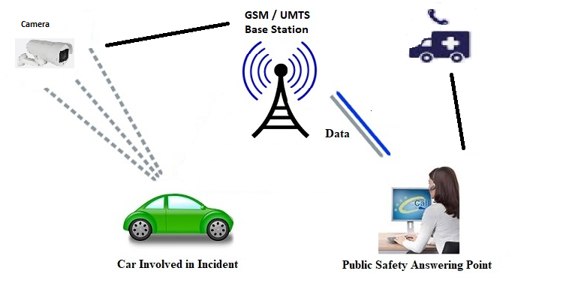

1. **Ambulance detection and open traffic:**

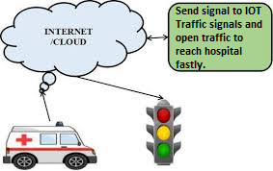

**Project milestones and deliverables:**

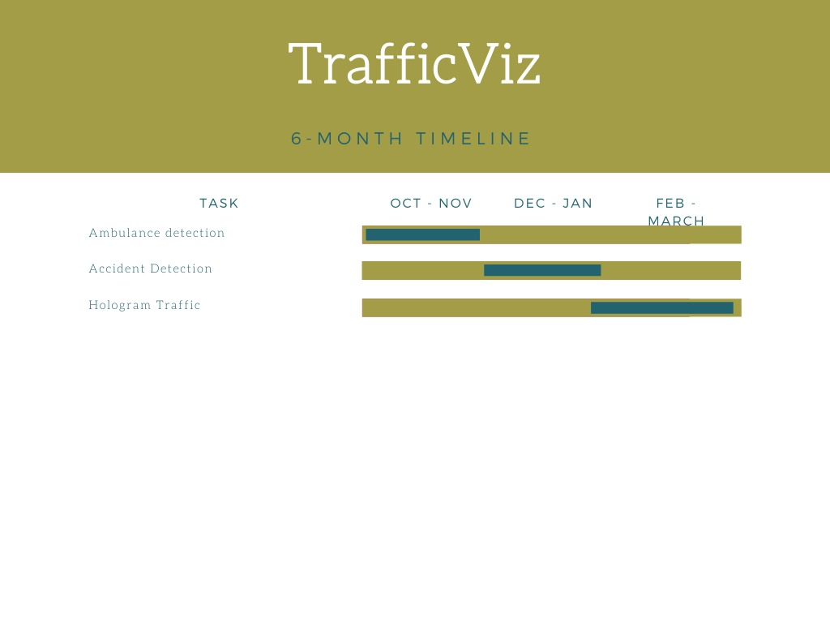

**References:**

1. Ghuloum, H. *3D hologram technology in learning environment*. in *Informing Science & IT Education Conference*. 2010.

2. Gonzalez, R.C., R.E. Woods, and S.L. Eddins, *Digital image processing using MATLAB*. 2004: Pearson Education India.

3. Sonika, S., K. Sathiyasekar, and S. Jaishree, *Intelligent accident identification system using GPS, GSM modem.* International Journal of advanced research in computer and communication engineering, 2014. **3**(2).

4. Kumar, M.E., et al. *Vehicle theft identification and intimation using gsm & iot*. in *IOP Conf. Ser. Mater. Sci. Eng*. 2017.

5. Goud, V., *Vehicle accident automatic detection and remote alarm device.* International Journal of Reconfigurable and Embedded Systems, 2012. **1**(2): p. 49.

6. Kattukkaran, N., A. George, and T.M. Haridas. *Intelligent accident detection and alert system for emergency medical assistance*. in *2017 International Conference on Computer Communication and Informatics (ICCCI)*. 2017. IEEE.

7. Shimobaba, T., et al. *Proposal of zoomable holographic projection method without zoom lens*. in *Proceedings of the International Display Workshops*. 2011.

8. Robin Johny, K. and E. Poorvika, *Holographic Infra Red Air Traffic Control.* WORLD. **3**: p. 2D.